2. Working with Maven: Creating a Maven Project, Understanding the POM File, Dependency Management and Plugins.
1: Install the Java JDK
- If you haven’t installed the Java JDK yet, you can follow the link below to download and install it. Download Java JDK from Oracle.
Working with Maven Project
Note: Always create separate folder to do any program.
- Open command prompt.
- mkdir program2 – this will create program2 folder.
- cd program2 – navigate program2 folder.
- After then follow the below step to working with Maven project.
Step 1: Creating a Maven Project
- You can create a Maven project using the mvn command (or through your IDE, as mentioned earlier). But here, I’ll give you the essential pom.xml and Java code.
- Type the command in command prompt as given below
mvn archetype:generate -DgroupId=com.example -DartifactId=myapp
-archetypeArtifactId=maven-archetype-quickstart -DinteractiveMode=false
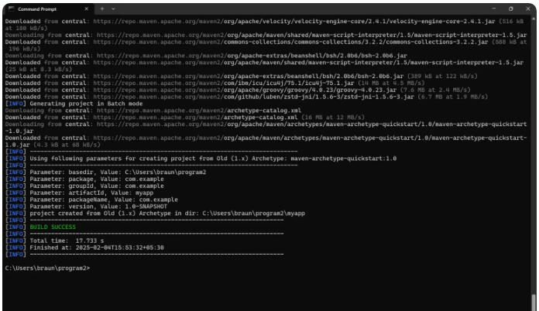
Note: See in your terminal below the project folder path showing after executing the cmd manually navigate the path and see the project folder name called myapp.
Step 2: Open The pom.xml File
- You can manually navigate the project folder named call myapp and open the file pom.xml and copy the below code and paste it then save it.
- In case if you not getting project folder then type command in your cmd.
  - cd myapp – is use to navigate the project folder.
  - notepad pom.xml – is use to open pom file in notepad.
Type the below code in POM file
<?xml version="1.0" encoding="UTF-8"?>
<project xmlns="http://maven.apache.org/POM/4.0.0"
xmlns:xsi="http://www.w3.org/2001/XMLSchema-instance"
xsi:schemaLocation="http://maven.apache.org/POM/4.0.0 http://maven.apache.org/xsd/maven-4.0.0.xsd">
<modelVersion>4.0.0</modelVersion>
<groupId>com.example</groupId>
<artifactId>myapp</artifactId>
<version>1.0-SNAPSHOT</version>
<dependencies>
<!-- JUnit Dependency for Testing -->
<dependency>
<groupId>junit</groupId>
<artifactId>junit</artifactId>
<version>4.13.2</version>
<scope>test</scope>
</dependency>
</dependencies>
<build>
<plugins>
<!-- Maven Surefire Plugin for running tests -->
<plugin>
<groupId>org.apache.maven.plugins</groupId>
<artifactId>maven-surefire-plugin</artifactId>
<version>2.22.2</version>
<configuration>
<redirectTestOutputToFile>false</redirectTestOutputToFile>
<useSystemOut>true</useSystemOut>
</configuration>
</plugin>
</plugins>
</build>
</project>
Step 3: Open Java Code (App.java) File
- Open a file App.java inside the src/main/java/com/example/ directory.
- After opening the App.java copy the below code and then save it.
package com.example;
public class App {
public int add(int a, int b) {
return a + b;
}
public static void main(String[] args) {
App app = new App();
int result = app.add(2, 3);
System.out.println("2 + 3 = " + result);
System.out.println("Application executed successfully!");
}}
Step 4: Open Java Code (AppTest.java) File
- Open a file AppTest.java inside the src/test/java/com/example/ directory.
- After opening the AppTest.java copy the below code and then save it.
package com.example;
import org.junit.Assert;
import org.junit.Test;
public class AppTest {
@Test
public void testAdd() {
App app = new App();
int result = app.add(2, 3);
System.out.println("Running test: 2 + 3 = " + result);
Assert.assertEquals(5, result);
}
}
Note: before building the project make sure you are in the project folder if not navigate the project folder type command in your command prompt cd myapp
Step 4: Building the Project
To build and run this project, follow these steps:
- Compile the Project by typing the below command in command prompt
mvn compile
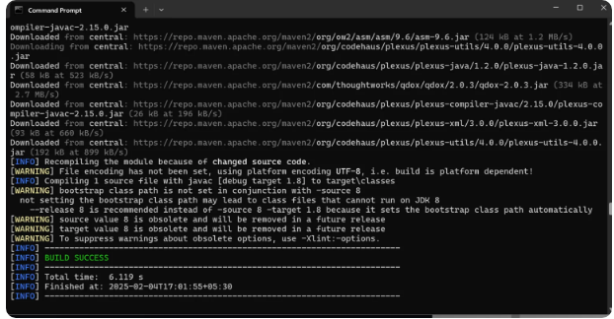
- Run the Unit Tests using the below command in command prompt
mvn test
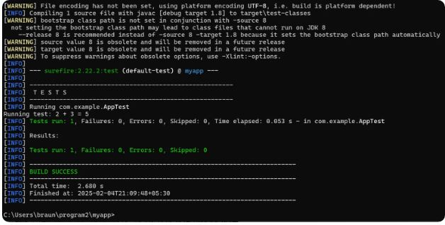
- Package the project into a JAR using the below command in command prompt
mvn package
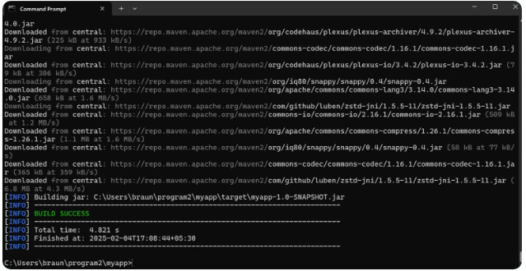
- Run the application (using JAR) by typing the below command
java -cp target/myapp-1.0-SNAPSHOT.jar com.example.App
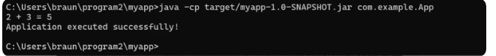
The above command is used to run a Java application from the command line. Here’s a breakdown of each part:
- java: This is the Java runtime command used to run Java applications.
- -cp: This stands for classpath, and it specifies the location of the classes and resources that the JVM needs to run the application. In this case, it’s pointing to the JAR file where your compiled classes are stored.
- target/myapp-1.0-SNAPSHOT.jar: This is the JAR file (Java ARchive) that contains the compiled Java classes and resources. It’s located in the target directory, which Maven creates after you run mvn package.
- com.example.App: This is the main class that contains the main() method. When you run this command, Java looks for the main() method inside the App class located in the com.example package and executes it.

